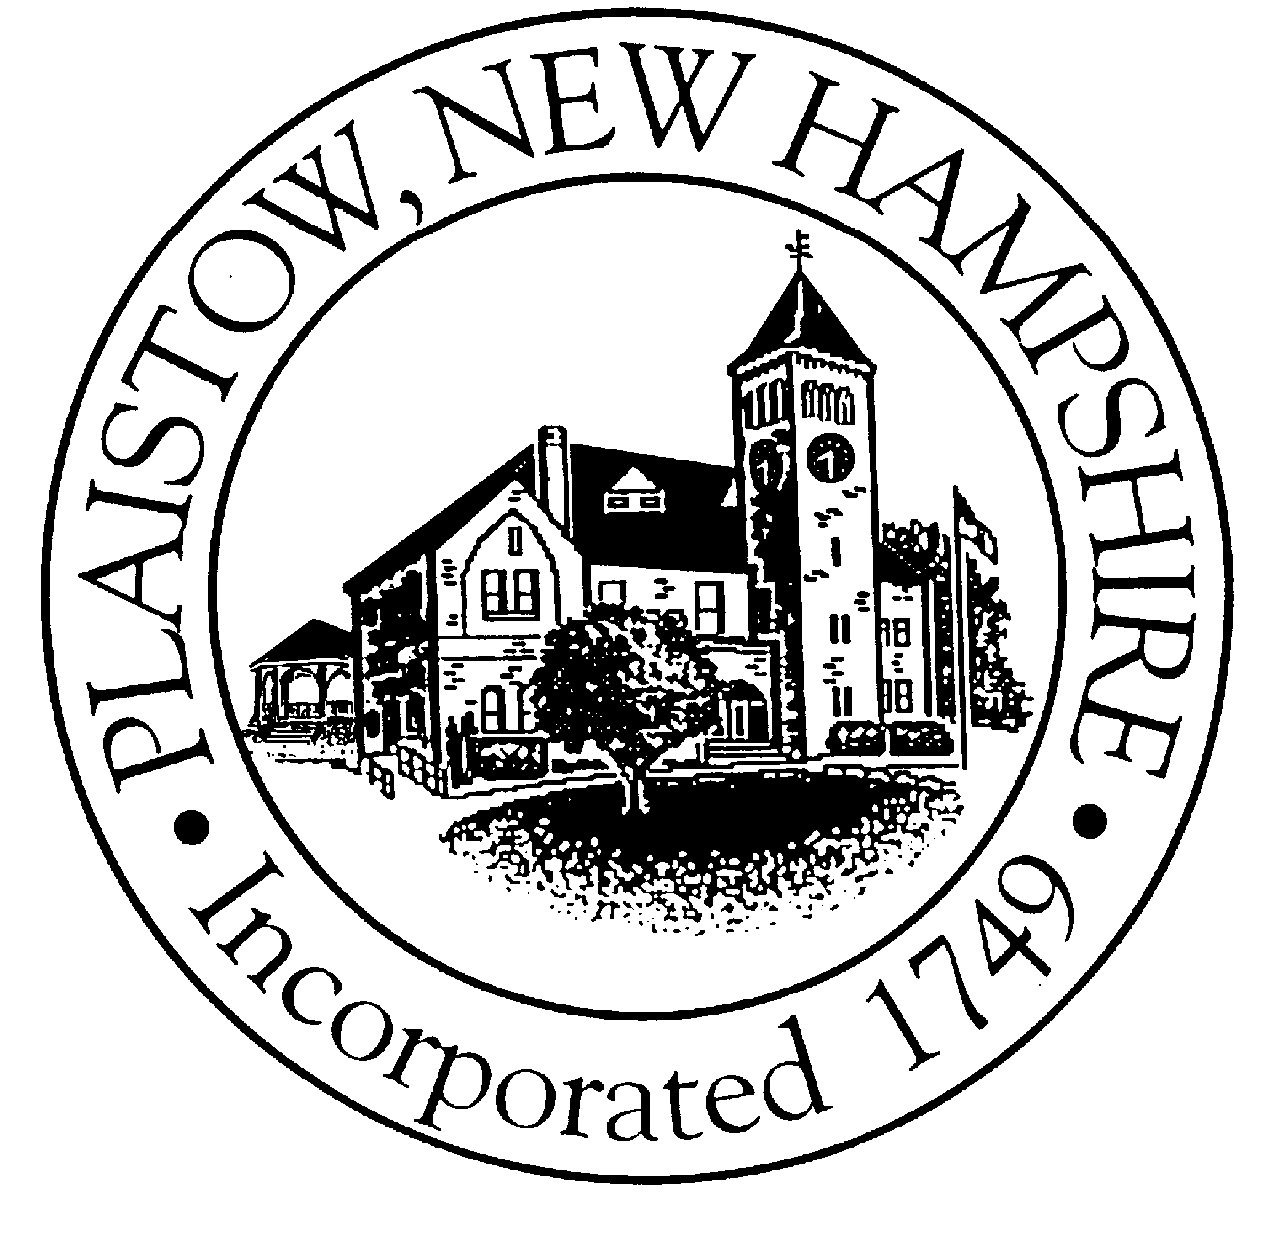

Office of the Planning Board

145 Main Street, Plaistow, NH 03865

Tel: 603-382-7371, Ext. 14 (Fax 382-7183)

AGENDA
PLAISTOW PLANNING BOARD
Date: Wednesday, February 6, 2008
Time: 6:30 P.M. - Plaistow Town Hall

- Meeting Convened

Timothy E. Moore
Chairman

Steven Ranlett
Vice Chairman

Robert Zukas

Barry Weymouth

Michelle Curran
Selectman
Ex-Officio

Neal Morin
Alternate

Merilyn Senter
Alternate

Lawrence Gil
Alternate
Selectman
Ex-Officio

Leigh Komornick
Town Planner

Mike Dorman
Chief Building Official

Dee Voss
Recording Secretary

- Roll Call

- Minutes of 1/10/08 and 1/16/08 Planning Board Meetings.

4) Presentation on the Public Safety Complex Expansion Project

5) A Preliminary Public Hearing/Discussion on a proposed 2-lot subdivision for property
located in the LDR and MDR Zones at 30 Kingston Road, Tax Map 53, Lot 16. The parcel
size is 2.6 +/- acres and has 320 +/- feet of frontage. The owner of record is Raymond
E. Roy.

6) Bond Release Request for Stateline Plaza

7) Review of Sign Ordinance Rotation Schedule from Dee

8) Other Business.

- Misc. Notices, Letters, Newspaper Articles and other Correspondence from Dept.
of Building Safety, Planning and ZBA;
- Any Other Business;

9) Adjournment.

(The Town of Plaistow complies with the Americans with Disabilities Act regulations. Please call 382-7371, Extension 14
between 9:00 a.m. to 4:30 p.m. if you have questions regarding accessibility in attending this meeting).

